 | PRINCIPAL HULL DATA | ENCL.
 | PRINCIPAL HULL DATA | REPORT
 | PRINCIPAL HULL DATA | DATE | 2026-06-06
 | PRINCIPAL HULL DATA | REF

SHIP: GNC Supply1
Loading condition: Design WL
Draught AP/FP: 5.956 / 6.044 [m]

Symbol Unit ——————————————————————————————————————————————————————————————
Length overall L_{OA} [m] 88.015
Length on designed waterline L_{WL} [m] 83.093
Length betw. perp. L_{PP} [m] 82.800
Breadth moulded B [m] 19.200
Breadth waterline B_{WL} [m] 19.200
Depth to 1st deck D [m] 14.000
Draught at L_{PP}/2 T [m] 6.000
Draught at FP T_{FP} [m] 6.044
Draught at AP T_{AP} [m] 5.956
Trim (pos. aft) t [m] -0.089
Rake of keel [m] 0.000
Rise of floor [m] 0.000
Bilge radius [m] 0.000
——————————————————————————————————————————————————————————————
Sea water density ρ_{s} [kg/m³] 1025.00
Shell plating thickness [mm] 2
Shell plating in % of displ. [%] 0.40
——————————————————————————————————————————————————————————————
Volume displacement ∇ [m³] 6200.9
Displacement Δ [t] 6381.3
Prismatic coefficient* C_{P} [-] 0.6545
Block coefficient* C_{B} [-] 0.6501
Midship section coefficient C_{M} [-] 0.9933
Longitudinal C.B. from L_{PP}/2 LCB [m] -5.261
Longitudinal C.B. from L_{PP}/2* LCB [% L_{PP}] -6.354
Longitudinal C.B. from AP LCB [m] 36.139
Wetted surface S [m²] 2011.15
Wetted surface of transom stern A_{T} [m²] 18.40
——————————————————————————————————————————————————————————————

Remarks: *Refers to L_{PP}
Hydrostatic corrections not included

ShipX (RepGen version 2.0.19) 08-Aug-2007 18:54:00 - Licensed to: NTNU

 | HYDROSTATICS | ENCL.
 | HYDROSTATICS | REPORT
 | HYDROSTATICS | DATE | 2026-06-06
 | HYDROSTATICS | REF

SHIP: GNC Supply1
Loading condition: Design WL
Draught AP/FP: 5.956 / 6.044 [m]

Symbol Unit ——————————————————————————————————————————————————————————————
Length overall L_{OA} [m] 88.015
Length betw. perp. L_{PP} [m] 82.800
Breadth moulded B [m] 19.200
Depth to 1st deck D [m] 14.000
Draught at L_{PP}/2 T [m] 6.000
Draught at FP T_{FP} [m] 6.044
Draught at AP T_{AP} [m] 5.956
Trim (pos. aft) t [m] -0.089
Rake of keel [m] 0.000
Rise of floor [m] 0.000
Bilge radius [m] 0.000
——————————————————————————————————————————————————————————————
Sea water density ρ_{s} [kg/m³] 1025.00
Shell plating thickness [mm] 2
Shell plating in % of displ. [%] 0.40
——————————————————————————————————————————————————————————————
Length on waterline L_{WL} [m] 83.093
Breadth waterline B_{WL} [m] 19.200
Volume displacement ∇ [m³] 6200.9
Displacement Δ [t] 6381.3
Prismatic coefficient* C_{P} [-] 0.6545
Block coefficient* C_{B} [-] 0.6501
Midship section coefficient C_{M} [-] 0.9933
Longitudinal C.B. from L_{PP}/2 LCB [m] -5.261
Longitudinal C.B. from L_{PP}/2* LCB [% L_{PP}] -6.354
Longitudinal C.B. from AP LCB [m] 36.139
Vertical C.B. VCB [m] 3.326
Wetted surface S [m²] 2011.15
Wetted surface of transom stern A_{T} [m²] 18.40
Waterplane area A_{W} [m²] 1389.50
Waterplane area coefficient C_{W}(L_{WL}) [-] 0.871
Longitudinal C.F. from L_{PP}/2 LCF [m] -10.569
Longitudinal C.F. from AP LCF [m] 30.831
——————————————————————————————————————————————————————————————
Immersion DP₁ [t/cm] 14.242
Trim moment MT₁ [t·m/cm] 89.065
Transverse metacenter above keel KM_{T} [m] 9.401
Longitudinal metacenter above keel KM_{L} [m] 116.027
——————————————————————————————————————————————————————————————

Remarks: *Refers to L_{PP}
Hydrostatic corrections not included

ShipX (RepGen version 2.0.19) 08-Aug-2007 18:54:05 - Licensed to: NTNU

 | DATA-CHECK PROPERTIES | ENCL.
 | DATA-CHECK PROPERTIES | REPORT
 | DATA-CHECK PROPERTIES | DATE | 2026-06-06
 | DATA-CHECK PROPERTIES | REF

Run name:

Ship name:GNC Supply1
Loading condition description: Design waterline

ShipX exported data
Main dimensions (from input):
______________________________________________________________

Length between perpendiculars (m) 82.800
Breadth (m) 19.200
Draught, midship (m) 6.000
Sinkage (m) 0.000
Trim, + = aft (deg) 0.000
______________________________________________________________

Hull data (from geometry):
______________________________________________________________

Hull sections 4 - 40
Hull length (m) 82.800
Hull breadth at mid section (m) 19.200
Hull draught at mid section (m) 6.000
______________________________________________________________

Coefficients for data check etc.:
Type Specified Calculated
______________________________________________________________

Displacement (tonnes) 6360.00 6362.21*
Vertical center of bouyancy, KB 3.334*
Vertical center of gravity, VCG 7.300*
Longitudinal center of bouyancy, LCB 36.014*
Longitudinal center of gravity, LCG 36.000 36.014*
Block coefficient, Cb 0.650 0.651
Water plane area coefficient, Cw 0.871 0.870
Prismatic coefficient, Cp 0.656
Mid section area coefficient, Cm 0.993 0.990*
Longitudinal metacentric height, GMl 103.628*
Transverse metacentric height, GMt 2.144*
Roll radius of gyration, r44 6.720*
Pitch radius of gyration, r55 20.700*
Yaw radius of gyration, r66 20.700*
Roll-yaw radius of gyration, r46 0.000*
______________________________________________________________

* - Applied in the hydrodynamic calculations

ShipX - 2007-08-08 - 6:54:49 PM - Licensed to: NTNU

 | HULL GRID | ENCL.
 | HULL GRID | REPORT
 | HULL GRID | DATE | 2026-06-06
 | HULL GRID | REF

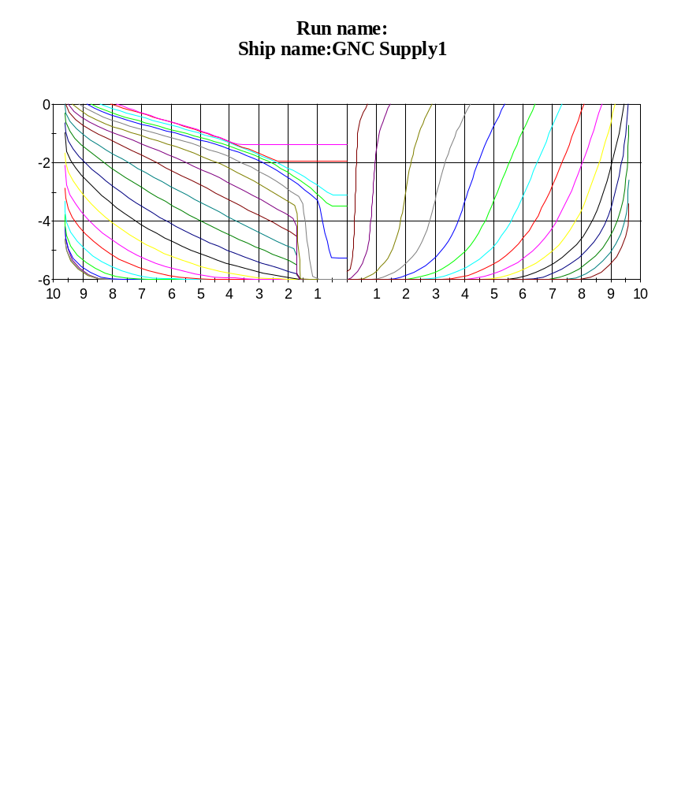

ShipX - 2007-08-08 - 6:54:49 PM - Licensed to: NTNU

